**Main Page**: From this page the user is able to navigate to the MicroWiki, The conference room finder & the world clock.

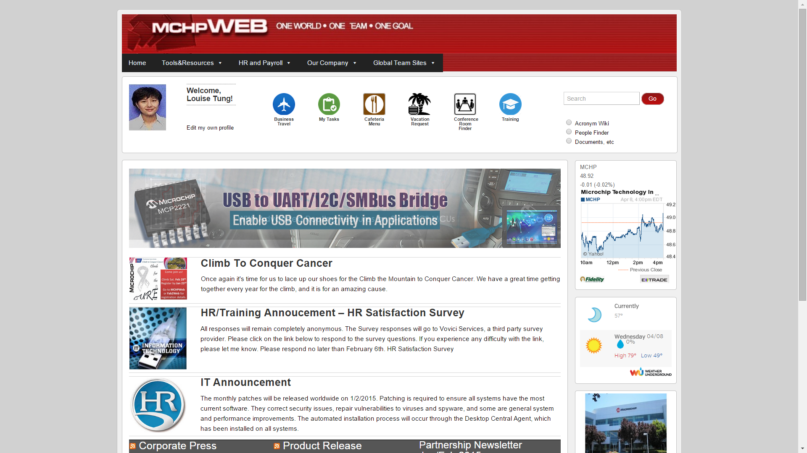

**Conference Room Finder:**

Step 1: To access the CRF, from the Home Page click on the Conference room finder icon in the icon ribbon left of the search bar on the top right hand corner.

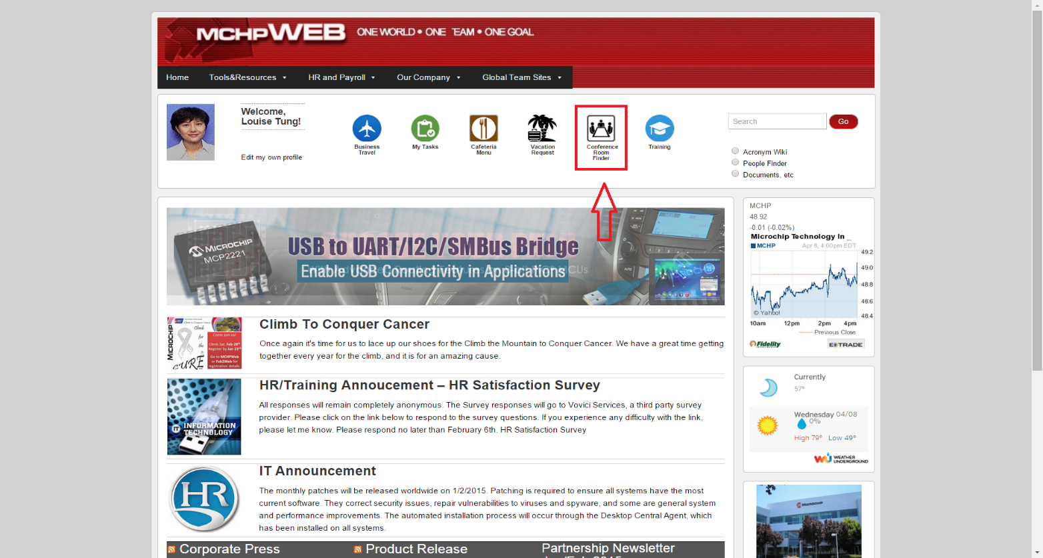

Step 2: Once you arrive on the conference room finder page like the one below, on the search bar below (not the search bar on the top right hand corner), please enter the conference room you will like to search.

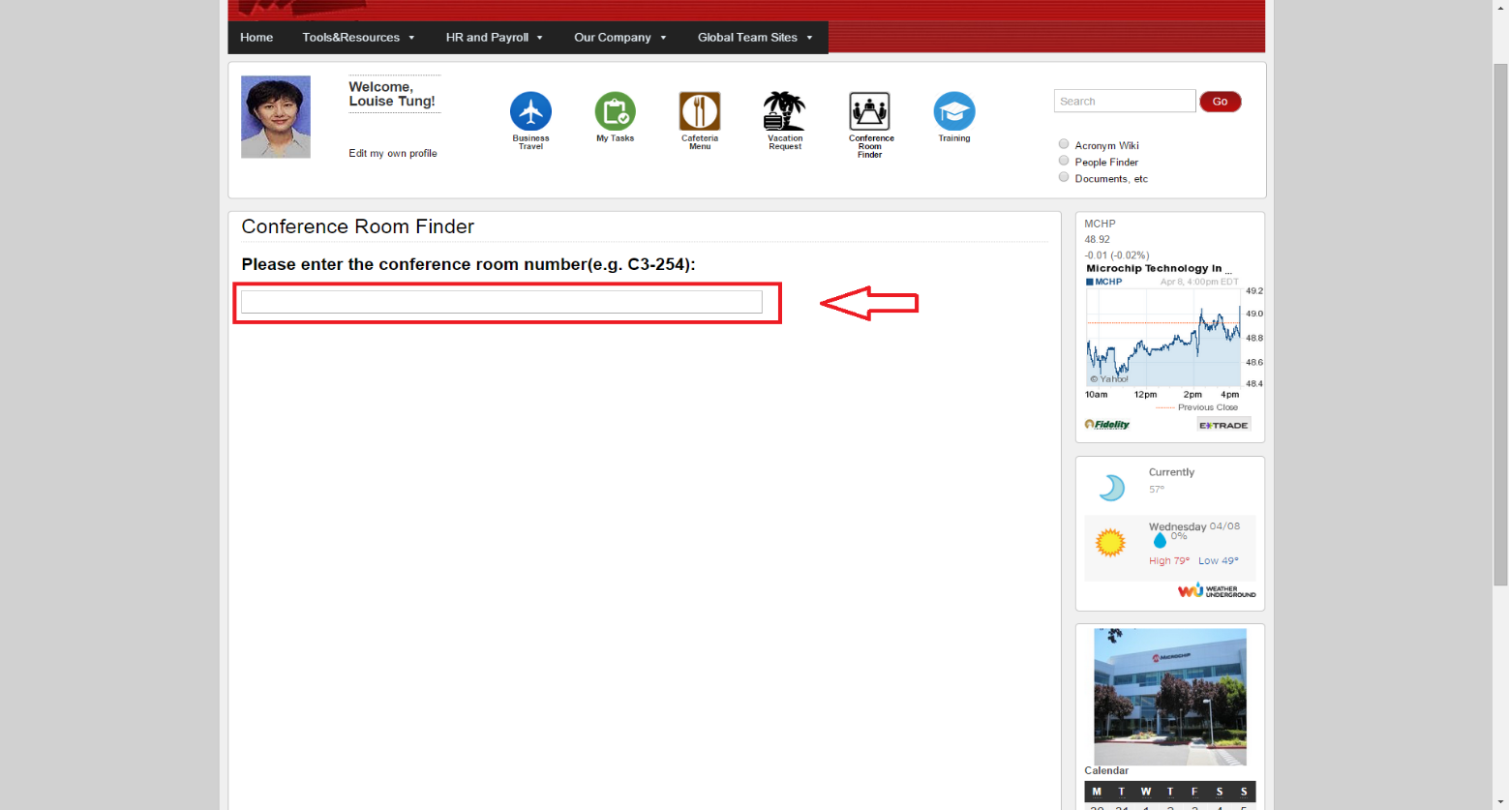

Step 3: Once you enter the first couple of letters of the conference room, it will show a recommended list, which you can choose from and once you have chosen a conference room, it will show a map of where the conference room is located like the picture below.

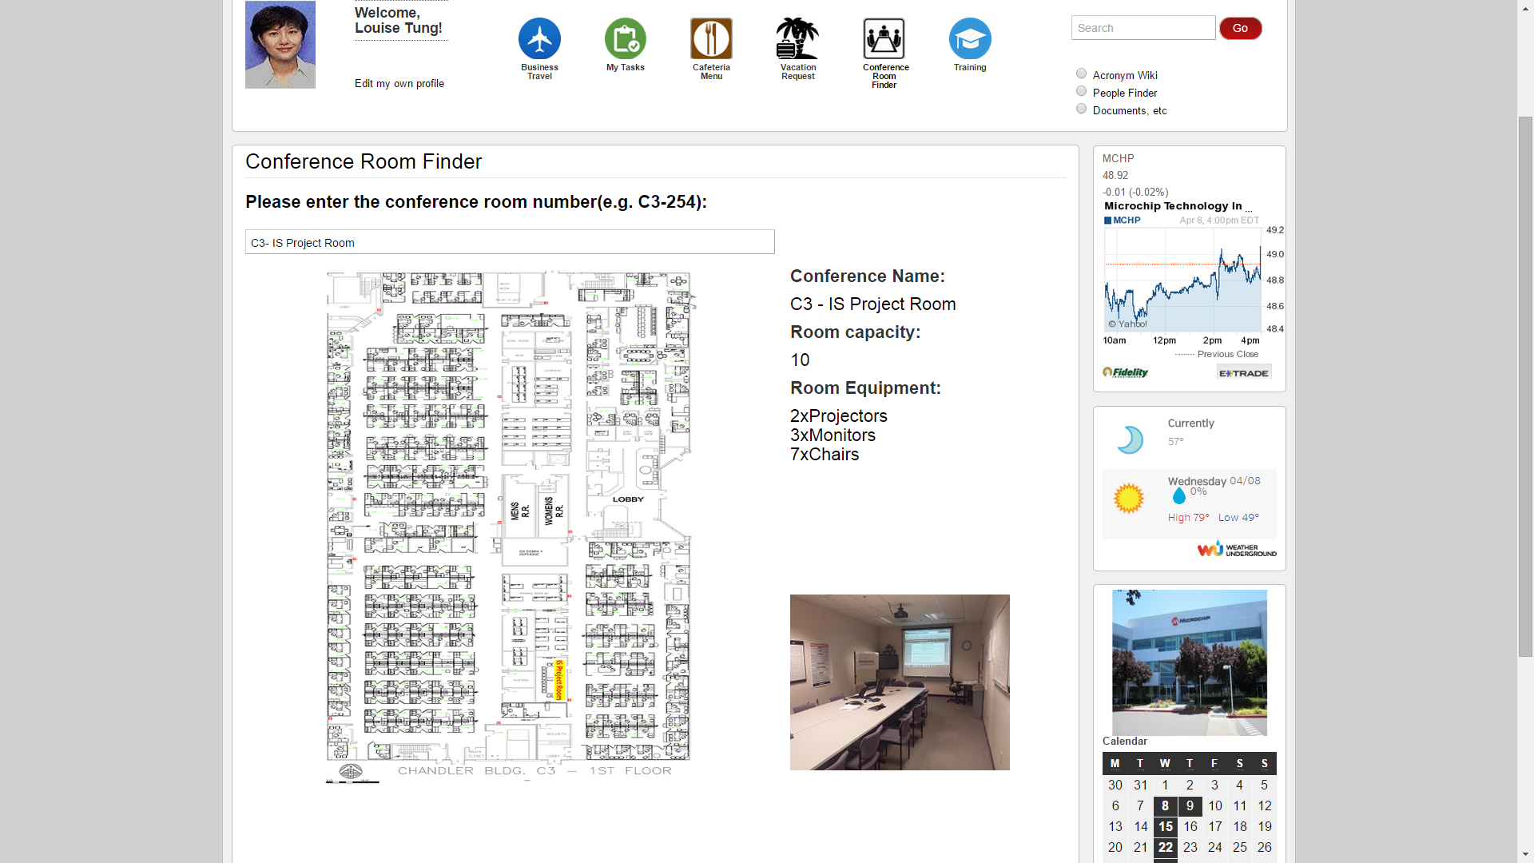

**MicroWiki Page:**

Step 1: To access the MicroWiki Page, from the main home page please click the Tools & Resources tab from the tool bar at the top of the page, which will drop down a menu; and from there please select “Acronym Wiki” right below conference room finder under the “Finder” sub menu.

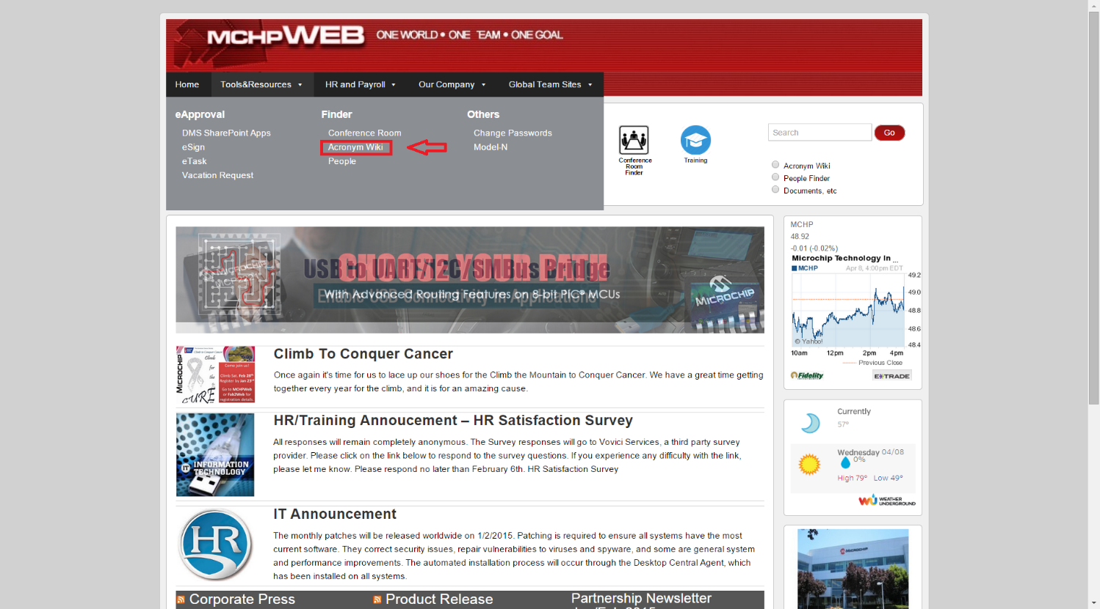

Step 2: Once you click “Acronym Wiki” you will be taken to the MicroWiki page which looks like this

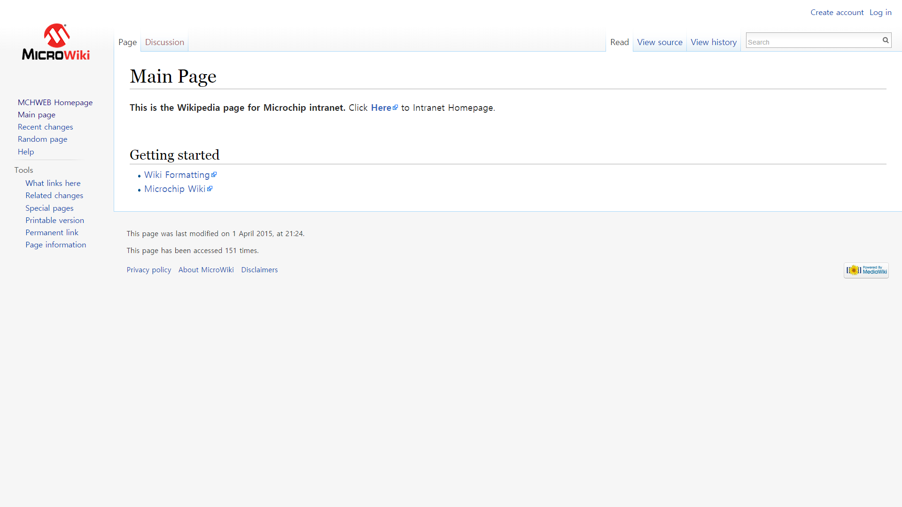

Step 3: From the MicroWiki Page user may now search or add an acronym. First to search type in the acronym you would like to search in the search bar in the top right hand corner just like Wikipedia.

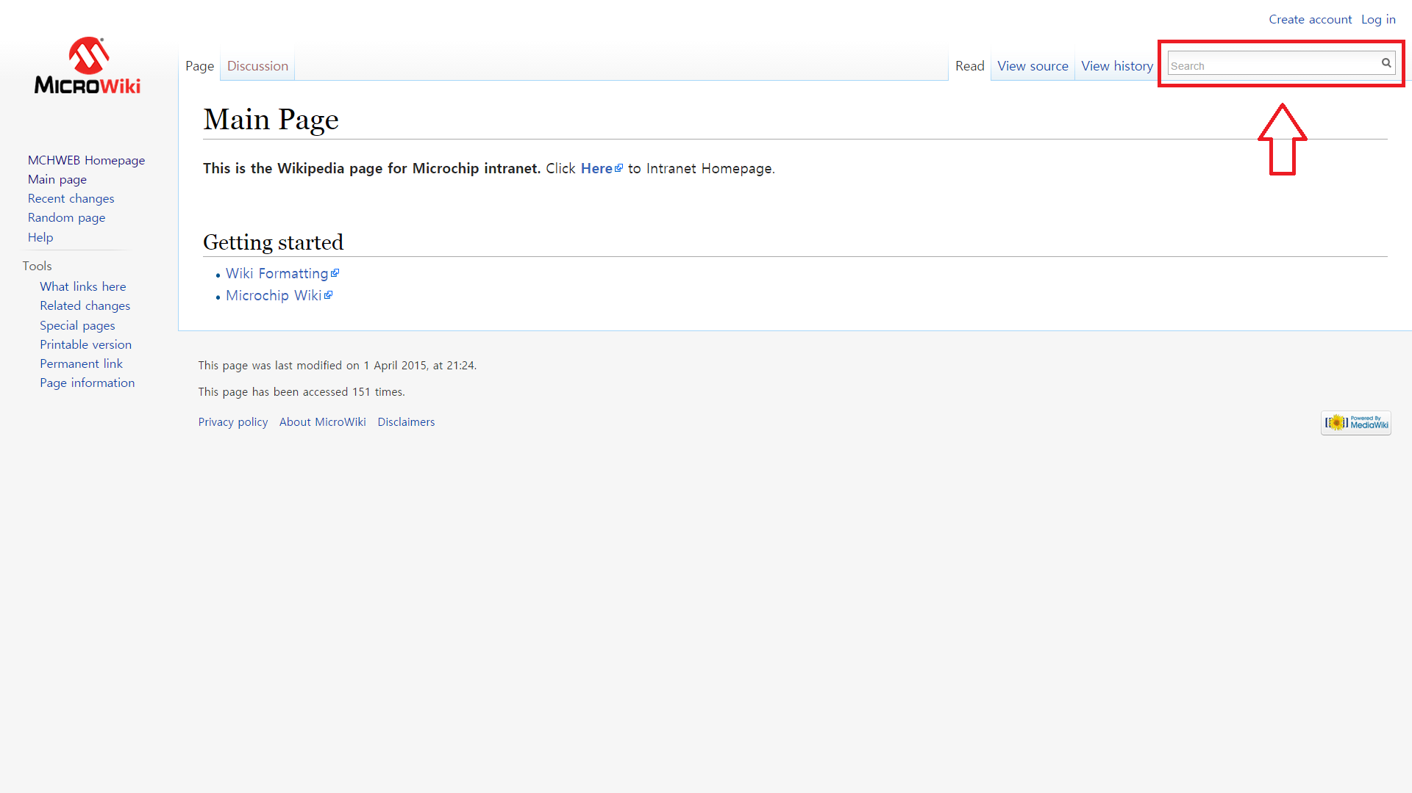

Step 4: Once you search word E.G: “DOS” you will be taken to a page which explains and defines the acronym.

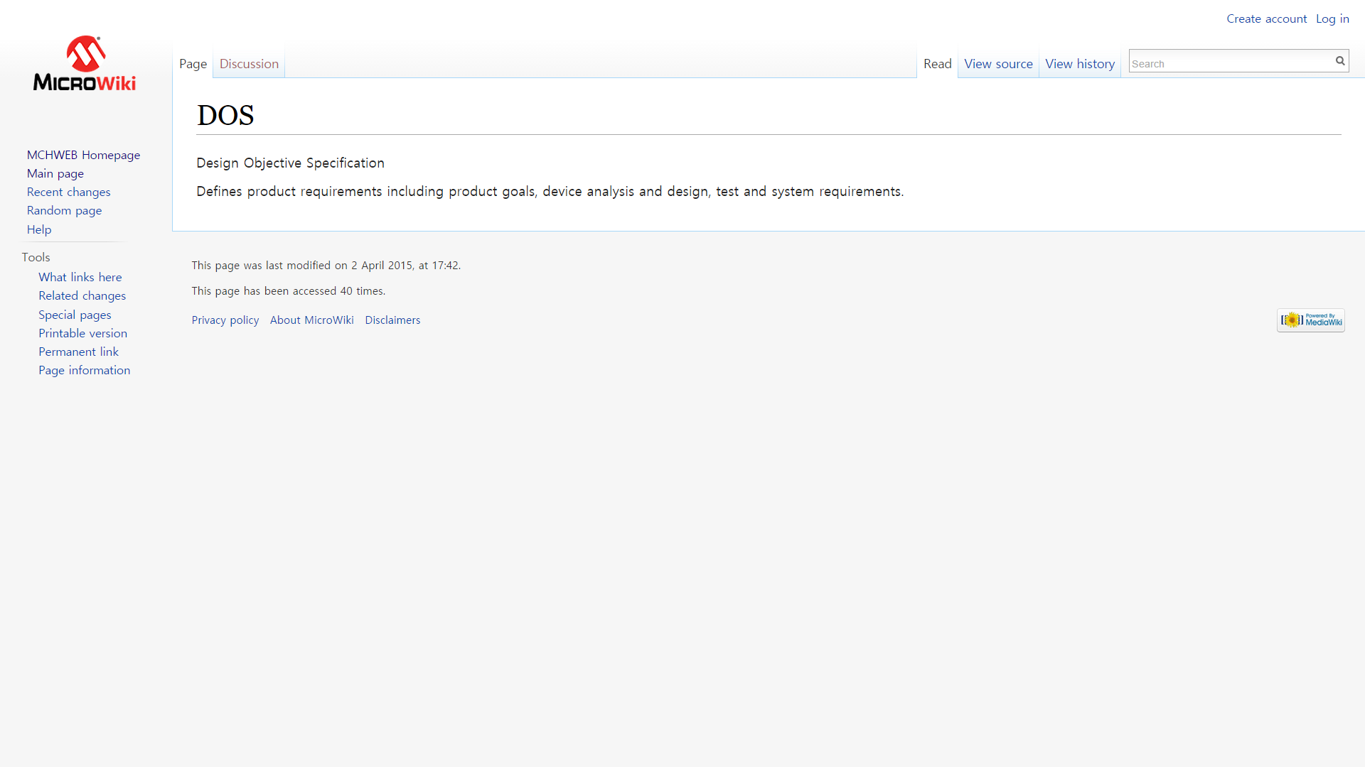

Step 5: Now to create a new acronym, the user must first log in or create an account with the MicroWiki Page:

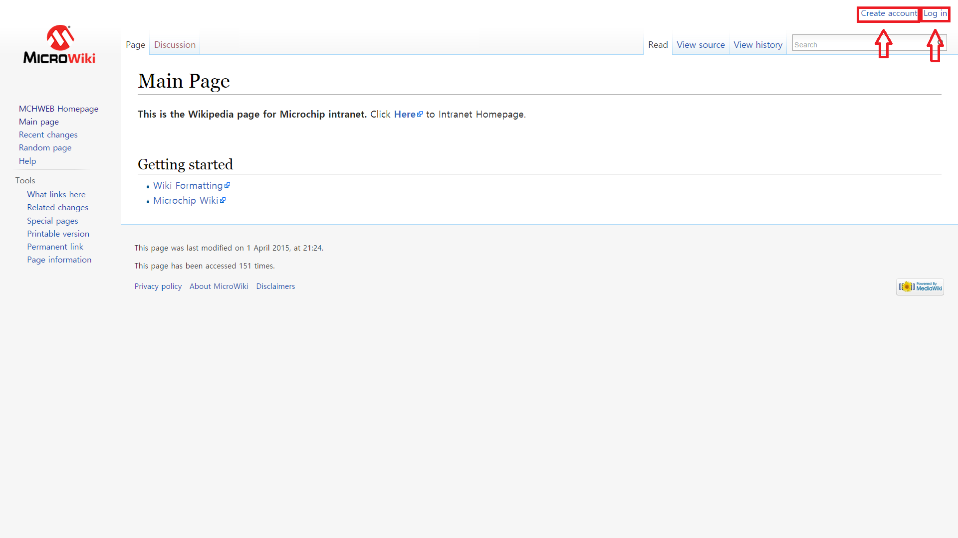

Step 6: Once you are logged in, the user is now given the right to add acronyms to the page, in order to do so the user must first search the acronym they wish to add

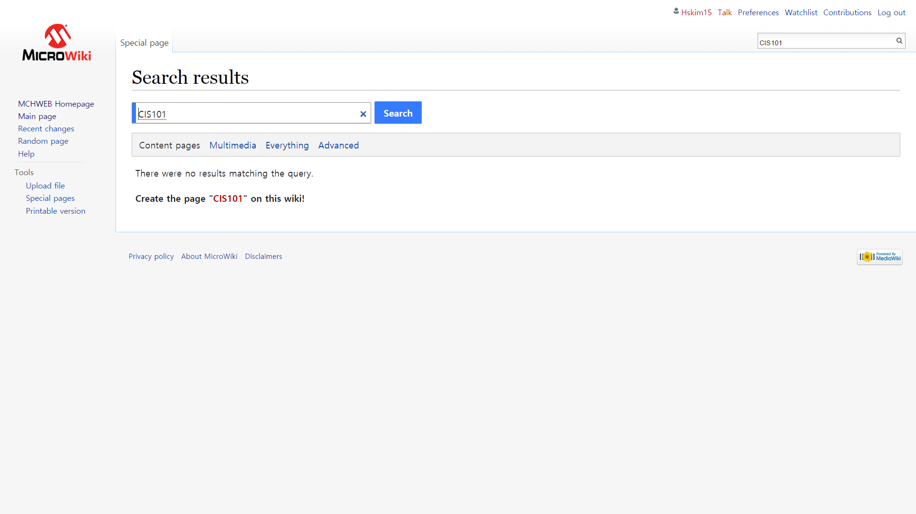

Step 7: Since the acronym does not yet exist in the wiki page, it will state that there were no results matching that query, and below it will state Create the Page “Acronym” on this wiki, you have to click the acronym within the quotations which will take you to a page where you can create a page for the specific acronym.

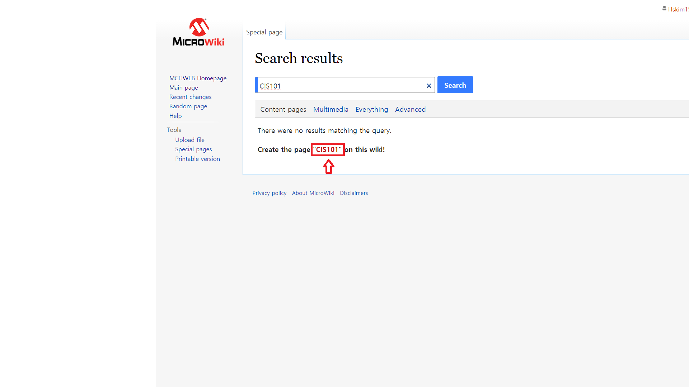

Step 8: Once you click on that acronym, it will take you to the page below, where the user can enter in the definition and explanation for that acronym

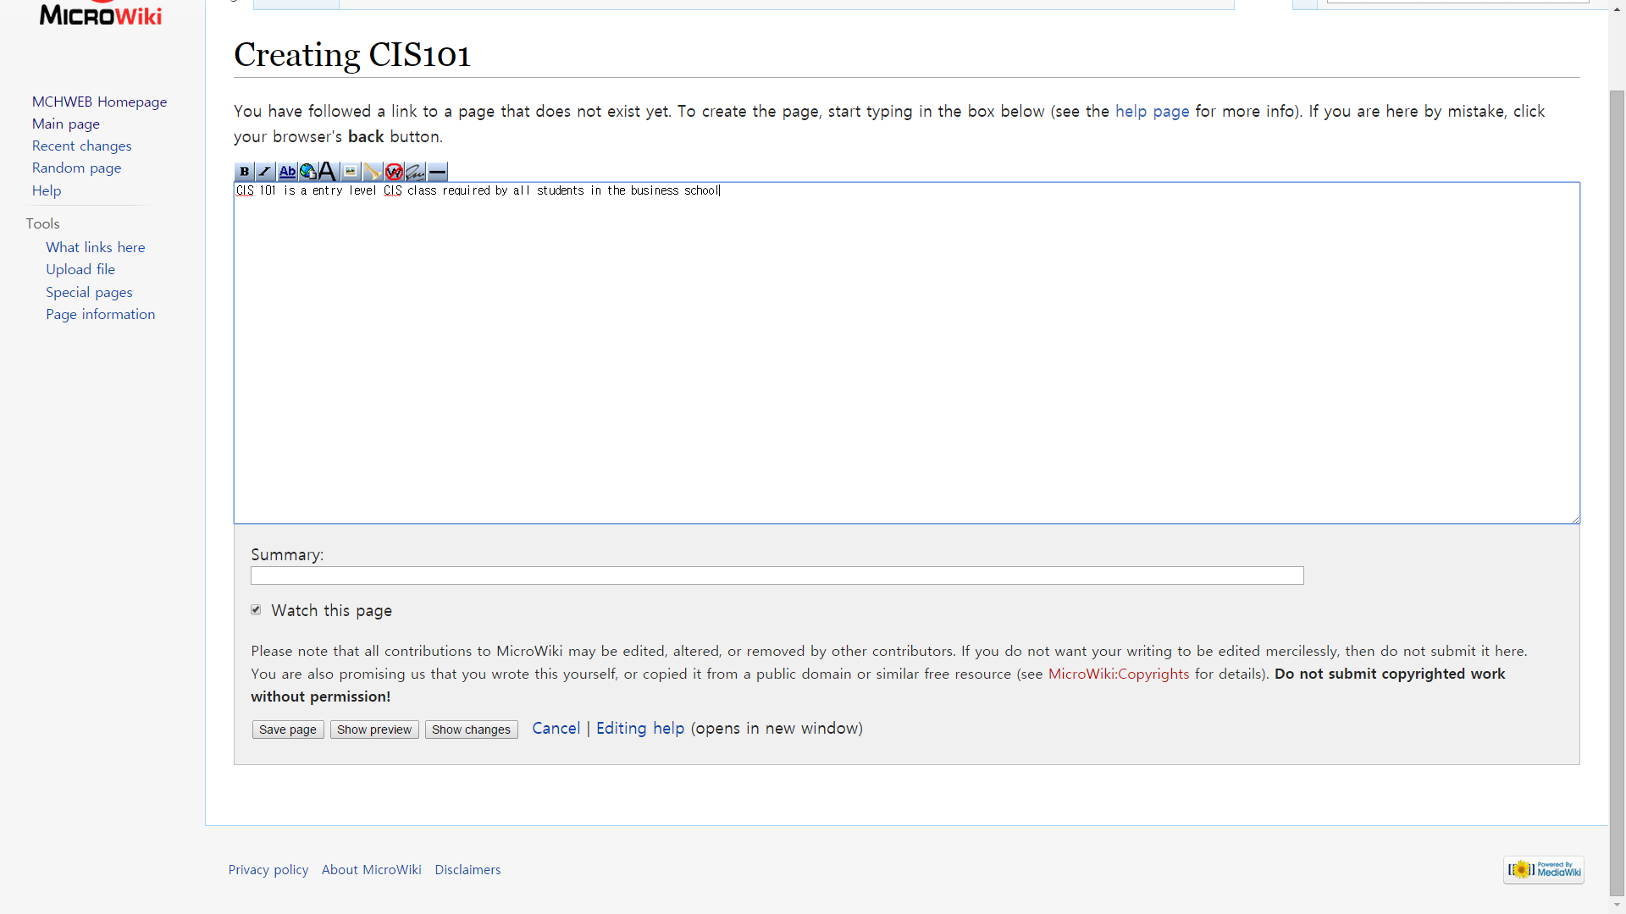

Step 9: Once you enter in the body information about the acronym, you will now hit the save page button on the bottom

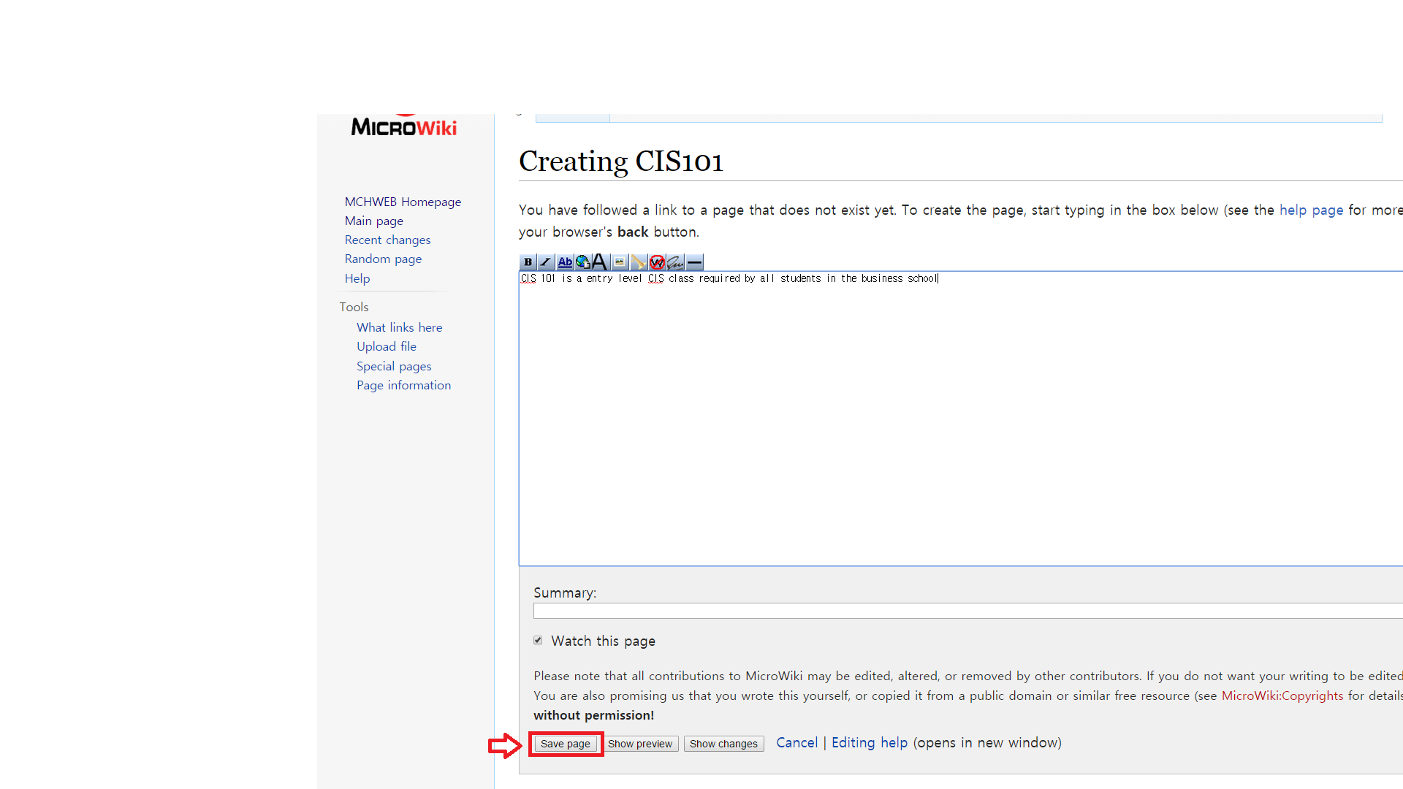

Step 10: Now once you hit Save Page button, you will be taken to the page for that new created acronym which is now searchable via the search bar on the Microwiki page.

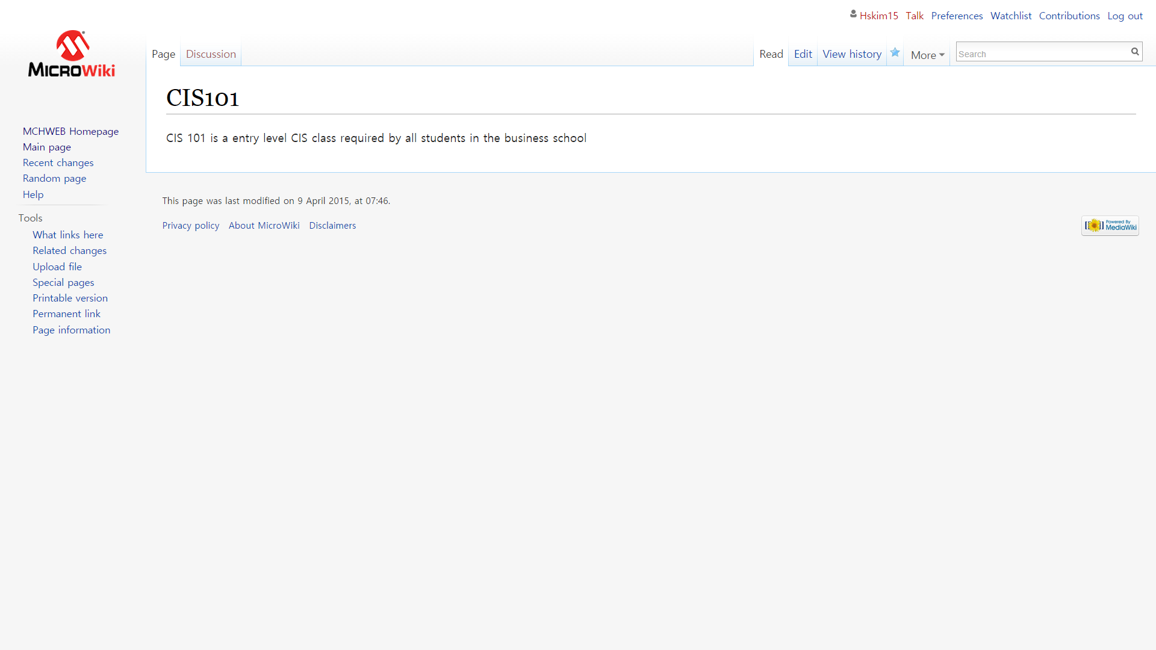

**World Clock:**

Step 1: To access the world clock, from the main page please select “Our Company” from the navigation bar on the top of the page and select “World Clock”

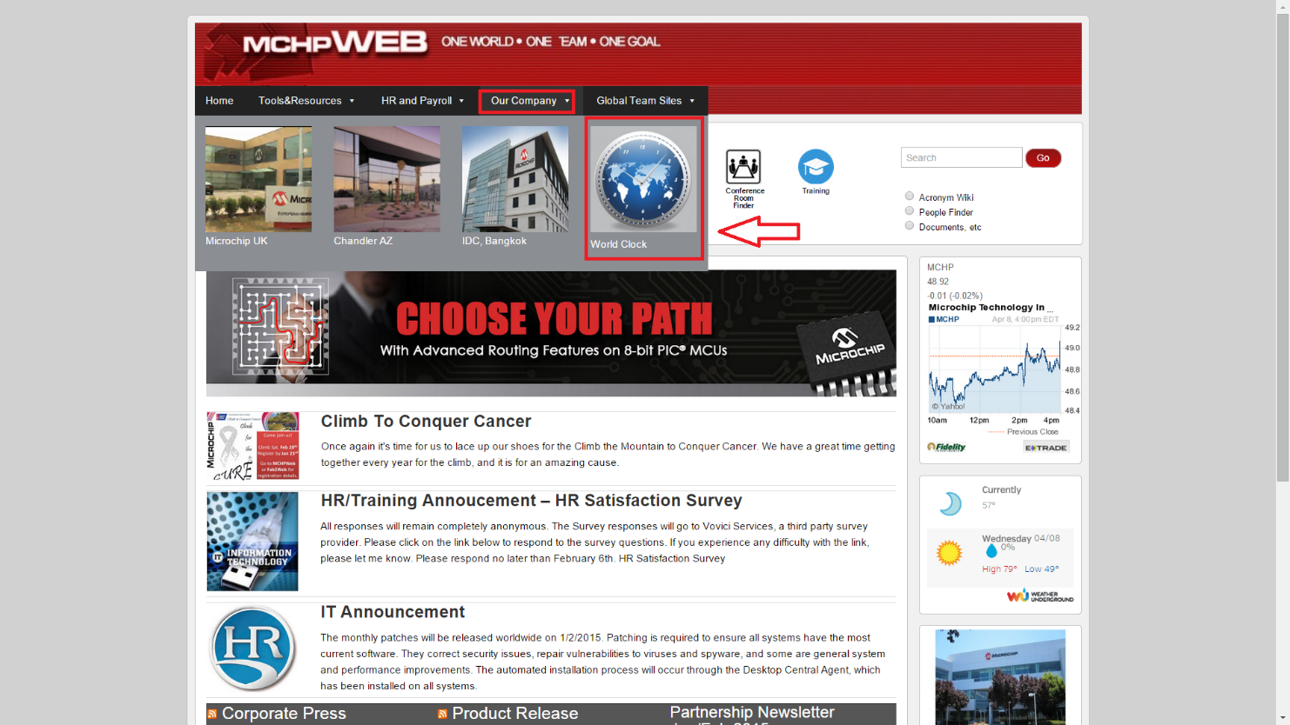

Step 2: Once you select “World Clock” it will take you to the World Clock Page, where it will show the time zones and other MicroChip locations around the world.

